Big Mountain Resort

# Problem Statement:

What are the options for Big Mountain Resort to maintain their profit margins at 9.2% this season through the use of newly installed chair lift even after incurring an extra operating cost due to installation of the additional chairlift?

# Recommendations:

After analyzing the data from other ski resorts of the country, below are the recommendations to be considered in order to maintain the profit margins:

* On analyzing the figure below, it can be clearly seen that in most of the Resorts in US, weekend ticket prices for adult are more than weekday ticket prices. Hence, it is recommended that there shall be two types of tickets- a cheaper one on weekdays and a bit costlier on weekends.  
  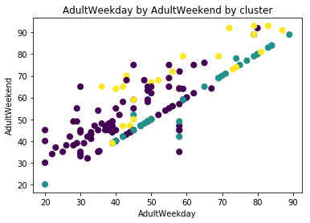
* It is also recommended to not install a chairlift for eight or six passengers as you can see in the below figures none of the resorts have these kind of chairlifts.  
  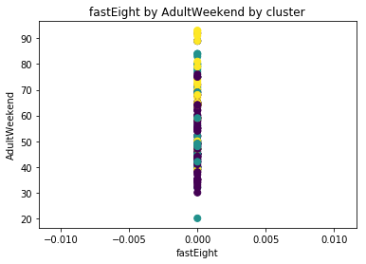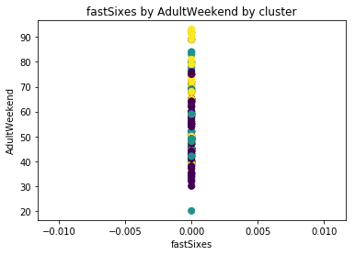
* As you can see in the below figure, most of the resorts in US which have atleast 1 four passenger fast chairlift installed have slightly higher weekend ticket prices. Hence, to get maximum out of the new installed chairlift, it is recommended to install a four passenger fast chairlift.  
  